Handout for Digital Lectures

To prepare for the digital lecture and to make participation as beneficial and smooth as possible, the handout provides some assistance in using the Zoom app.
Zoom offers a wide range of functions for meetings and digital lectures, as well as the advantage that you can participate in the respective online events with almost any Internet-capable device. However, we recommend that you use a computer connected to the Internet with an ethernet cable. For further information, please refer to Section 1 - Technical Requirements.
Contents
1. Technical requirements 1
1.1 Participation using a computer 1
1.2 Participation using a tablet or smartphone 1
2. Install Zoom software 1
3. Join the Digital Lecture 1
4. Recording 2
5. Functions for participation in discussions 2
5.1 Chat function 3
5.2 Raising your hand 3
5.3 Questions and answers (Q&A) 3
5.4 Surveys 3

Technical requirements

Participation using a computer
To participate in a digital lecture, you need a computer with one of the following operating systems
- Windows 7 or higher
- MacOS from 10.7
- Linux
and an Internet connection that is as stable as possible (with an ethernet cable, WLAN, LTE or 3G).

  - Participation using a tablet or smartphone
The following sections describe how to install Zoom, join the digital lecture, and operate the Zoom software on a computer during the digital lecture. You can also participate in the digital lecture using a tablet or smartphone with an iOS or Android operating system. In this case, please install the Zoom app from the Apple AppStore or Google PlayStore. The range of functions is basically the same as on the computer; however, due to the smaller screen, the operation of Zoom on mobile devices differs from this handout in some places.

Install Zoom software
It is possible to participate in the digital lecture without the Zoom software, for example, if you use the Chrome browser. However, the Zoom app offers some advantages, so we recommend using the app.
To participate in the Zoom digital lecture, simply click on the link you find on the respective event website. This opens a window in your browser (e.g. Edge, Internet Explorer, Chrome, Firefox, Safari ...). If the download does not take place automatically, please select the required file according to your operating system: https://zoom.us/download.
If the Zoom software is already installed on your computer (for example, because you have already participated in a Zoom video conference), your computer will automatically start Zoom. Otherwise, your browser will now first initiate the installation of the Zoom program on your computer. How exactly this process works and how it is displayed on your screen depends on your computer's operating system and security settings; therefore, it is not possible to provide general step-by-step instructions. In any case, the installation process should be largely automatic and only a few manual confirmations should be necessary. After installation, you will find the Zoom program icon on your computer (either in the Start menu and/or on the desktop).

Join the Digital Lecture
Step 1
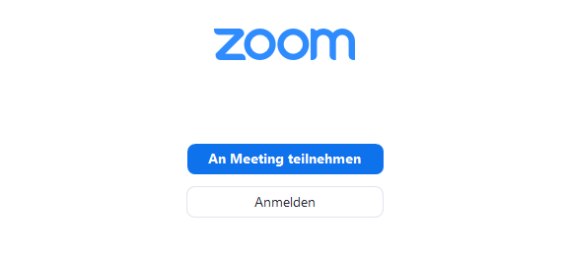
After you have installed the Zoom program, start Zoom by clicking on the program icon. This will open the home screen: Click on the blue "Join meeting" button.
Figure 1: Login window of the Zoom app
Step 2
Click on the blue "Join meeting" button. We would be happy if you would provide your full name, but you do not have to do this.
You will then be asked to enter your email address. This will not be verified, but it is required for further participation.
In the next step, you are automatically admitted to the digital lecture hall. If you see the message "Please wait for the host to start this webinar", please be patient for a few minutes until the lecture hall is opened.

Recording
This digital lecture will be recorded to be used for the Kolleg’s media library. Only the speaker, his or her presentation and the moderator will be heard or seen in the recording. Chat contributions as well as questions and answers are not recorded. A "REC" sign in the upper right-hand corner of the screen informs the participants that the event is being recorded.

Functions for participation in discussions
The digital lecture is structured in such a way that you automatically receive the lecturer’s presentation and video feed. As long as the presentation has not yet been opened, you will initially only see a black test screen with the name of the presenter or speaker.
In Zoom there are various possibilities for interactive participation, of which, however, only the "Questions and Answers" tool can be used in the digital lecture.
Figure 2: Toolbar for interactive functions

Chat function
We have blocked the chat function from our site. For questions on the content and in case of technical problems, please use the tool "Questions and Answers" (Q&A) during the digital lecture.

Raising your hand
We have blocked the function “raise your hand” from our site. For questions on the content and in case of technical problems, please use the tool "Questions and Answers" (Q&A) during the digital lecture.

Questions and answers (Q&A)
Using the Q&A tool, you can ask both questions related to the topic or technical problems and address them to the moderator or the speaker. Here too, the moderators have the opportunity to interact with you. Questions that are asked via Q&A are also visible to other participants - but you can hide your name in the question by clicking on the "send anonymously" box. The question will then be assigned to an "anonymous viewer".
All participants have the opportunity to comment on questions in the Q&A or to mark them as particularly important for them with the 'thumbs up' sign. We would like to encourage you to use the Q&A tool and its sub-functions for content-related questions.
The time at which your questions are answered is at the discretion of the presenter. We assume that the discussion will usually take place after the end of the digital lecture, but we would like to encourage you to ask your questions during the lecture.

Surveys
Zoom offers participants the opportunity to join in surveys. Surveys are triggered by the presenter and displayed by Zoom in real time. Please note that single selection of answers as well as multiple selection of answers is possible. The respective answer mode depends on the settings made by the presenter and is marked in brackets in the question. You will be informed about the result of the survey as soon as the presenter releases the result.
Please note that if you do not use the Zoom app, the survey tool may not function properly. If you use Zoom in a browser, you must allow pop-ups to display both the questions and the survey results.
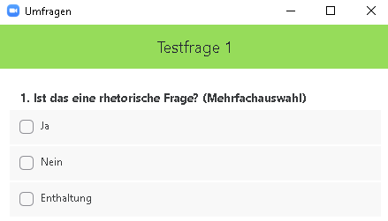

Figure 3: Sample question with multiple selections possible

